## VISVESVARAYA TECHNOLOGICAL UNIVERSITY

**“Jnana Sangama”, Belagavi-560014, Karnataka**



**A SUBJECT SEMINAR REPORT ON**

***“Tapchan and Salter’s Duck System”***

Submitted in partial fulfillment of the requirements for the Seminar

**Bachelor of Engineering**

**In**

### Computer Science & Engineering

**Submitted By**

**KISHOR N**

**(1SV21CS038)**

Under the guidance of

**Mr.SUTHAN R B.E., M.Tech.,MISTE**

Assistant Professor, Dept. of CSE.



**Department of Computer Science and Engineering**

**SHRIDEVI INSTITUTE OF ENGINEERING AND TECHNOLOGY**

**(Affiliated To Visvesvaraya Technological University) Sira Road, Tumkur – 572106, Karnataka.**

**2023-24**

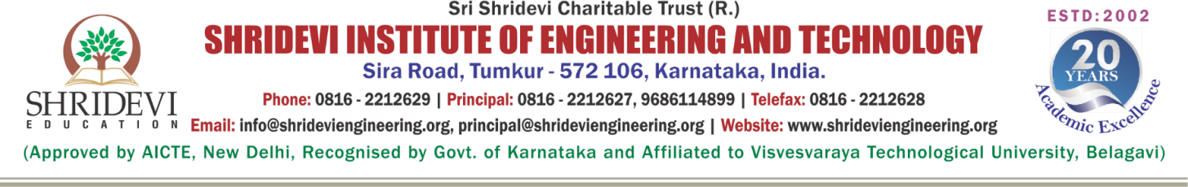

# Department of Computer Science and Engineering

## CERTIFICATE

**Certified that the Subject Seminar entitled**

**“*Tapchan and Salter’s Duck System*”**

## Carried out by

## KISHOR N[1SV21CS038]

A bonafide Student of Shridevi Institute Of Engineering And Technology has successfully carried out a Subject Seminar of RENEWABLE ENERGY RESOURCES (21EE652) in VI Semester, Bachelor of Engineering in CSE, VTU , Belagavi during 2023-24.All the corrections indicated for the internal assessments have been incorporated in report. The Subject Seminar has been approved as it satisfies the academic requirements in respect to the Seminar work.

**---------------------------------------- ---------------------------------------**

**Signature of Course Instructor Signature of HOD**

**Mr.Suthan R B.E., M.Tech., MISTE Dr. Basavesha D**

Assistant Prof., Dept. of CSE HOD, Dept. of CSE



# Department of Computer Science and Engineering

**Evaluation of Seminar**

|  |  |  |
| --- | --- | --- |
| **Evaluation Rubrics** | **Max Marks** | **Allotted Marks** |
| **Presentation** | **10** |  |
| **Report** | **05** |  |
| **Q&A** | **05** |  |
| **Total** | **20** |  |

Signature of Course Instructor